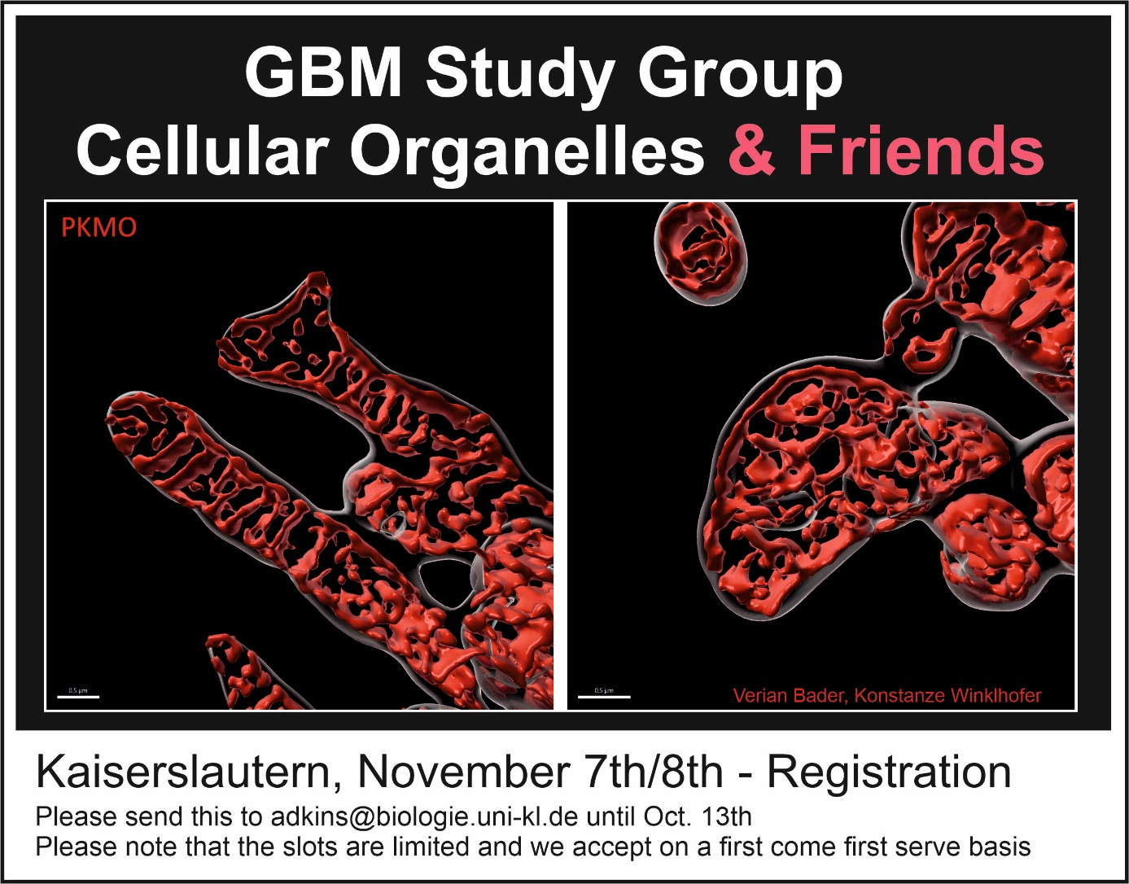
University of Kaiserslautern, Germany. 67663 KL. Erwin-Schrödinger-Strasse 57 (Rotunde)
Please send to Simone Adkins (adkins@biologie.uni-kl.de) – 0631 2052492.

I will participate at the meeting. I am aware that the organizers do not provide accommodation or transport. There is no registration fee.

Name:
University:
Department:
I would like to show a poster: yes ( ) no ( )

If selected, I would be happy to give (short) talk: yes ( ) no ( )

Title:
Co-authors:
Abstract (max. 150 words):

