

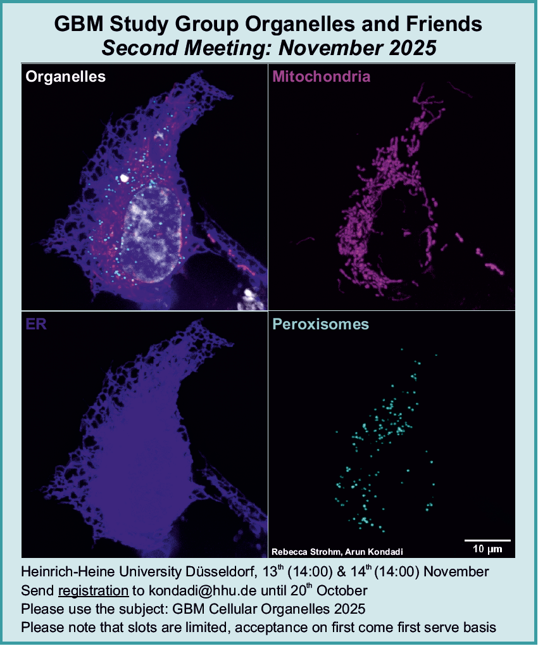

Participant Name:

Department:

University:

I would like to present a poster: Yes ( ) No ( )

If selected, I would be happy to present a (short) talk: Yes ( ) No ( )

Title:

Co-authors:

Abstract (max. 150 words):

I will participate in the GBM Study Group, Cellular Organelles, 2025 Annual meeting and I am aware that the organizers do not provide accommodation or transport.

*There is no registration fee. The exact details of the venue in Düsseldorf will be sent out in due time. Please send email to* [*kondadi@hhu.de*](mailto:kondadi@hhu.de) *(Dr. Arun Kondadi, UKD, HHU) with subject GBM Cellular Organelles 2025 until 20th of October.*